**Lab3. Handling exceptions**

1. Add at least three exception handling sections that trap all three different types of exceptions (pre-defined, non-predefined, user-defined).

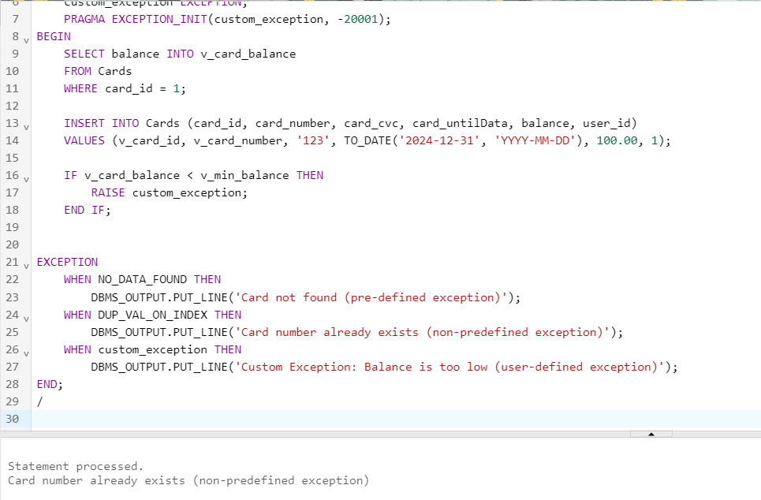

DECLARE

v_card_balance DECIMAL(10, 2);

v_min_balance DECIMAL(10, 2) := 100.00;

v_card_id INT := 1;

v_card_number VARCHAR2(16) := '1234567890123456';

custom_exception EXCEPTION;

PRAGMA EXCEPTION_INIT(custom_exception, -20001);

BEGIN

SELECT balance INTO v_card_balance

FROM Cards

WHERE card_id = 1;

INSERT INTO Cards (card_id, card_number, card_cvc, card_untilData, balance, user_id)

VALUES (v_card_id, v_card_number, '123', TO_DATE('2024-12-31', 'YYYY-MM-DD'), 100.00, 1);

IF v_card_balance < v_min_balance THEN

RAISE custom_exception;

END IF;

EXCEPTION

WHEN NO_DATA_FOUND THEN

DBMS_OUTPUT.PUT_LINE('Card not found (pre-defined exception)');

WHEN DUP_VAL_ON_INDEX THEN

DBMS_OUTPUT.PUT_LINE('Card number already exists (non-predefined exception)');

WHEN custom_exception THEN

DBMS_OUTPUT.PUT_LINE('Custom Exception: Balance is too low (user-defined exception)');

END;

/

1. Try incorporating exception handling into the anonymous blocks you created in lab 2.

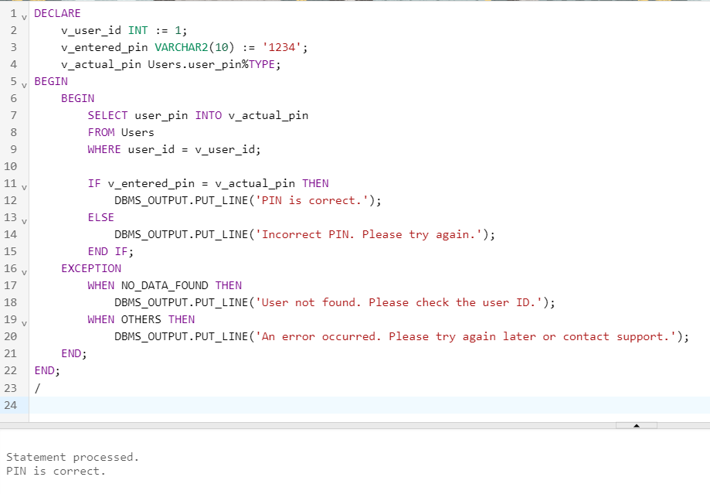

DECLARE

v_user_id INT := 1;

v_entered_pin VARCHAR2(10) := '1234';

v_actual_pin Users.user_pin%TYPE;

BEGIN

BEGIN

SELECT user_pin INTO v_actual_pin

FROM Users

WHERE user_id = v_user_id;

IF v_entered_pin = v_actual_pin THEN

DBMS_OUTPUT.PUT_LINE('PIN is correct.');

ELSE

DBMS_OUTPUT.PUT_LINE('Incorrect PIN. Please try again.');

END IF;

EXCEPTION

WHEN NO_DATA_FOUND THEN

DBMS_OUTPUT.PUT_LINE('User not found. Please check the user ID.');

WHEN OTHERS THEN

DBMS_OUTPUT.PUT_LINE('An error occurred. Please try again later or contact support.');

END;

END;

/

Questions:

1. What is an exception?
2. What types of exceptions exist in PL/SQL?
3. How are exceptions handled?
4. Describe the structure of the exception handling section.
5. What are predefined Oracle server errors and how are they handled?
6. What are non-predefined Oracle server errors and how are they handled?
7. What are user-defined exceptions and how are they handled?

DECLARE

v_user_id INT := 2;

v_uname VARCHAR2(255);

v_ulastname VARCHAR2(255);

v_card_number VARCHAR2(16);

v_loan_sum DECIMAL(10, 2);

BEGIN

SELECT uname, ulastname

INTO v_uname, v_ulastname

FROM Users

WHERE user_id = v_user_id;

SELECT card_number, loan_sum

INTO v_card_number, v_loan_sum

FROM Cards c

JOIN Loan l ON c.user_id = l.user_id

WHERE c.user_id = v_user_id;

DBMS_OUTPUT.PUT_LINE('User ID: ' || v_user_id || ', Username: ' || v_uname || ', Last Name: ' || v_ulastname|| ', Card Number: ' || v_card_number || ', Loan Sum: ' || v_loan_sum);

EXCEPTION

WHEN NO_DATA_FOUND THEN

INSERT INTO Users (user_id, uname, ulastname, uphone_number, user_password, user_pin, mybank_id)

VALUES (v_user_id, 'Anthony', 'Stark', '+1234567890', 'password', '5555', 1);

COMMIT;

END;

/

SELECT * FROM USERS WHERE USER_ID = 2;